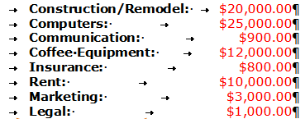
Indents & Tabs Assignment
If you have not done so, review lesson #8 before continuing. On this document you should:
- Use spell check to remove all the red spelling and green grammar marks WITHOUT changing the text.
- Below the line, give the first paragraph a 0.5 inch first line indent
- Give the second paragraph a 0.5 inch hanging indent
- Under the two paragraphs, recreate the above table. Your first tab should be a Left Tab set at 1.5 inches, your second a right tab set at 4.5 inches. Bold the words and change the font color of your numbers.
Lorem ipsum dolor sit amet, consectetur adipisicing elit, sed do eiusmod tempor incididunt ut labore et dolore magna aliqua. Ut enim ad minim veniam, quis nostrud exercitation ullamco laboris nisi ut aliquip ex ea commodo consequat. Duis aute irure dolor in reprehenderit in voluptate velit esse cillum dolore eu fugiat nulla pariatur. Excepteur sint occaecat cupidatat non proident, sunt in culpa qui officia deserunt mollit anim id est laborum
Lorem ipsum dolor sit amet, consectetur adipisicing elit, sed do eiusmod tempor incididunt ut labore et dolore magna aliqua. Ut enim ad minim veniam, quis nostrud exercitation ullamco laboris nisi ut aliquip ex ea commodo consequat. Duis aute irure dolor in reprehenderit in voluptate velit esse cillum dolore eu fugiat nulla pariatur. Excepteur sint occaecat cupidatat non proident, sunt in culpa qui officia deserunt mollit anim id est laborum

