**Tabs, Color, and Indenting on the ruler**

Directions on this document: **1)** Make the words below look EXACTLY like the picture **2)** make the bullets 18 point font, **3)** Use the ruler to adjust the placement of the bullet and tab (LOOK AT THE PICUTRE, **4)** Match all the colors as best you can, **5)** delete these directions and the picture so your list is on one page.

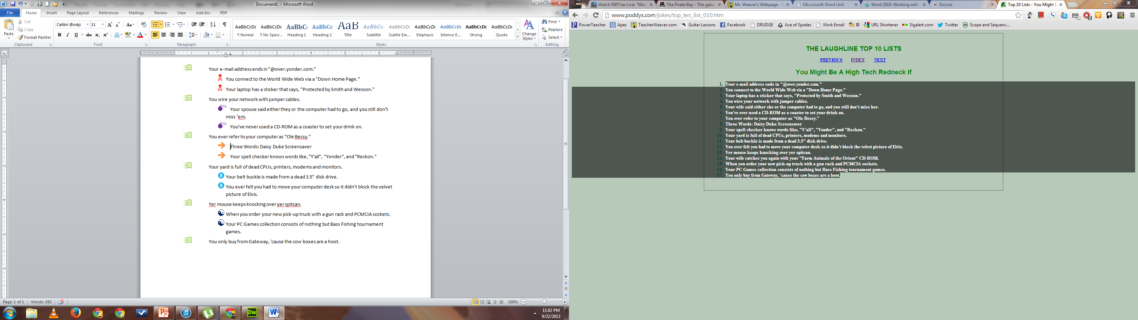

Your e-mail address ends in "@over.yonder.com."

You connect to the World Wide Web via a "Down Home Page."

Your laptop has a sticker that says, "Protected by Smith and Wesson."

You wire your network with jumper cables.

Your spouse said either they or the computer had to go, and you still don't miss ‘em.

You've never used a CD-ROM as a coaster to set your drink on.

You ever refer to your computer as "Ole Bessy."

Three Words: Daisy Duke Screensaver

Your spell checker knows words like, "Y'all", "Yonder", and "Reckon."

Your yard is full of dead CPUs, printers, modems and monitors.

Your belt buckle is made from a dead 3.5" disk drive.

You ever felt you had to move your computer desk so it didn't block the velvet picture of Elvis.

Yer mouse keeps knocking over yer spitcan.

When you order your new pick-up truck with a gun rack and PCMCIA sockets.

Your PC Games collection consists of nothing but Bass Fishing tournament games.

You only buy from Gateway, 'cause the cow boxes are a hoot.