Click for enlargement | Title, year, Author | Style of art | How does this painting reflect the Revolution in the Arts during the 1920s?
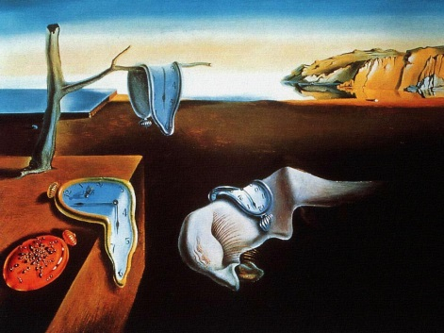 | The Persistence of Memory , 1931, Salvador Dalí
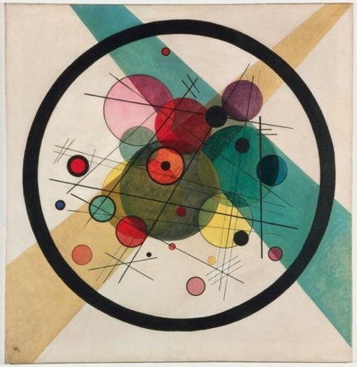 | Circles in a Circle, 1923, Wassily Kandinsky
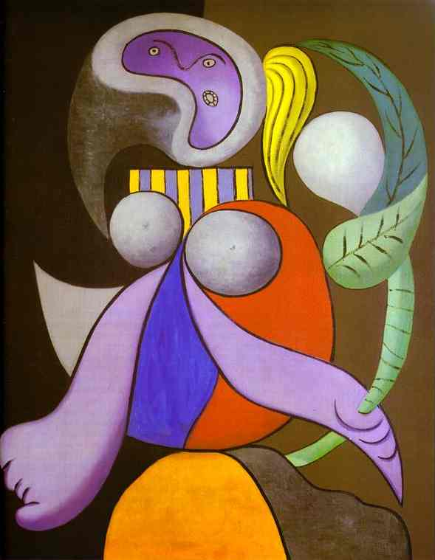 | Woman with a Flower, 1932 by Pablo Picasso
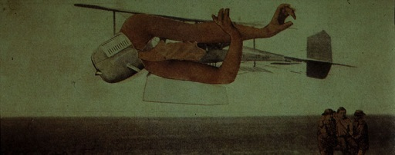 | Murdering Airplane, 1920, Max Ernst

